NoteBot AI

1st Harsh Pandey
Research Scholar,AIT Department Chandigarh University
Mohali, Punjab, India 21bcs4517@cuchd.in

4th Pramanshu Prajapati Research Scholar,AIT Department Chandigarh University
Mohali, Punjab, India 21bcs4510@cuchd.in

2nd Kirtan Nahar
Research Scholar,AIT Department Chandigarh University Mohali, Punjab, India
21bcs8762@cuchd.in

5th Sanskar Gautam
Reseach Scholar,AIT Department Chandigarh University Mohali,
Punjab, India
21bcs4553@cuchd.in

3rd Aditya Bhardwaj
Research Scholar,AIT Department Chandigarh University Mohali, Punjab, India 21bcs4507@cuchd.in

5th Sonal Rattan
Assistant Professor, AIT Department Chandigarh University Mohali, Punjab, India

Abstract “Noteshwar AI – is an intelligent platform that enables a unique combination of intelligence by improving the way users interact with their notes and documents. Through advanced data analysis and processing, Noteshwar AI enables users to load data, create comprehensive explanations, and understand query terms to derive insights that are answered. Noteshwar AI leverages a SaaS architecture built with Next.js, React, Prisma, and tRPC to provide a scalable, functional, and personalized user experience. Its features include real-time data analysis, flexible options, and the ability to store across LangChain and Pinecone to meet the needs of different users, especially students and professionals. This new solution not only redefines writing, but also increases productivity and retention of knowledge in a user-friendly web-based environment. NLP, Next.js, React, productivity, customization.
Key Words — Noteshwar AI, note-taking platform, artificial intelligence, SaaS, document analysis, NLP, Next.js, React, productivity, customization.

- INTRODUCTION
In today’s digital-first environment, the way people interact with information is evolving, with a focus on efficient and intelligent technology that supports learning and productivity. Essay writing, which is important for students, professionals, and lifelong learners, has shifted from traditional writing methods to digital platforms. However, most current digital solutions are not effective in context-sensitive content retrieval, personalization, and intelligent interaction. As a result, users are often constrained by limited functionality, rigid interactions, and the inability to seamlessly connect with data management and intelligent questioning. There is an urgent need for a new platform that will redefine digital writing through better accessibility, interactivity, and user-friendly design.
Noteshwar AI – a cutting-edge platform designed to transform the note-taking space through AI-driven data interactions. Designed to be more than just a digital notebook, Noteshwar AI allows users to upload documents, generate text and rich content, and understand the context of questions to get clear, relevant answers. Using a combination of advanced learning models, natural language processing, and scalable SaaS models, Noteshwar AI provides a revolutionary user experience that enables multiple use cases. The platform is built using technologies like Next.js, React, Prisma, and tRPC that deliver high performance and robustness.

Noteshwar AI is designed to facilitate continuous and effective learning by providing intelligent services tailored to the unique needs of each user. It uses advanced AI such as LangChain for memory persistence and Pinecone for vector storage to enhance data retrieval and seamless interaction experience. Additionally, features such as customizable content and instant search data make it a versatile tool that adapts to different interests and tasks.
In summary, Noteshwar AI addresses the limitations of traditional and digital note-taking platforms by providing intelligent solutions that enhance productivity, knowledge retention, and collaboration with users. The powerful system, user-friendly design, and intelligence-based features make Noteshwar AI a pioneering tool in digital knowledge management.
- LITERATURE REVIEW
The Evolution of Digital Note-Taking Systems
Digital note-taking tools have evolved over the years, evolving from traditional note-taking systems to interactive platforms that offer a wide variety of media and organization. Research shows that good writing skills are associated with better comprehension and retention, especially for students and professionals working with complex materials (Mueller & Oppenheimer, 2014). Traditional notebooks like Microsoft OneNote and Evernote provide powerful study tools but lack advanced content recognition capabilities, leaving a gap for skilled professionals who can help people use questions and understand text in different ways. Differences from traditional digital writing tools are the basis for innovations like Noteshwar AI, which uses artificial intelligence to deliver deep, meaningful language-focused writing to users.
Developing smart, AI-driven subscriptions requires a combination of processes, design, and tools to deliver efficient and effective user experiences. Recent advances in artificial intelligence (AI), linguistic processing (NLP), and software-as-a-service (SaaS) architecture are paving the way for many solutions to digital note-taking challenges. The implementation of this technology on platforms like Noteshwar AI is driven by proven processes and procedures to increase efficiency and usability.
Agile methods are widely used in software development and provide a stable process for the development of complex applications, especially those that require the integration of innovation and human usage strategies (Beck et al., 2001). Agile’s emphasis on development and flexibility is particularly important for AI-focused platforms such as Notehwar AI, where continuous improvement based on user interaction is important. By following agile principles, Notehwar AI can prioritize user input, allowing the platform to continuously adapt to user needs while reducing risks and high-performance management.
- EXISTING SYSTEM
The ‘Noteshwar AI’ platform is a new note-taking app designed to revolutionize the experience of capturing, organizing, and storing information. The platform offers a variety of cutting-edge features designed to enhance productivity, learning, and user satisfaction by integrating artificial intelligence.
- Smart Note Organization
The "Smart Note Organization" function uses AI-based classification to capture user notes. The app uses natural language processing (NLP) to analyze each document to determine its content and tags and categorize them accordingly, simplifying document retrieval. These features adjust to the user's preferences, giving groups their own identities and changing them as they write more.
The system is built using HTML, CSS, JavaScript, ReactJS, and a Node.js backend. This powerful technology ensures seamless and efficient processing of user data. Users can easily enter text, making the experience clean and fast. The backend API built using Node.js is responsible for processing data and storing notes in the construction file for efficient processing.

- Smart Notes Saving:
The ‘Smart Note Saving’ function uses AI and machine learning algorithms to help users save notes. When users add annotations, Noteshwar AI analyzes the content and automatically divides it into appropriate tags, topics, or folders. This smart classification reduces manual sorting, saves time, and makes document retrieval easier. Scripts can be saved and structured instantly using a user-friendly interface built using HTML, CSS, JavaScript, ReactJS, and NextJS, providing a great experience. The app also allows users to upload metadata such as date, time, location, and custom identifiers to make searches more powerful. Under the scenes, the Node.js server handles the backend, processing data efficiently and retrieving data quickly, while ReactJS handles the social, responsive frontend.

- AI-Powered Search:
Noteshwar AI’s ‘AI Search’ feature recycles data using NLP (natural language processing) to understand the context of user queries. Unlike simple search, this allows users to search for articles by asking questions or referring to topics related to the article’s content, tags, or related topics. The app uses AI to provide searchable and accurate content, make data ingestion more efficient, and provide a better user experience. Built using machine learning libraries like TensorFlow or PyTorch, the features learn from user interactions and evolve over time to make search results more accurate and personalized.

- Collaborative Notes:
The "Collaborative Notes" feature allows users to instantly share and edit posts with others. This feature is implemented by WebSockets, which facilitates instant updates and allows multiple users to work on the same document simultaneously. It provides a common workspace where users can collaborate on discussions, business ideas, or a shared experience. ReactJS powers the interface, ensuring edits are instantly synced for a seamless collaboration experience.
The interface is built using ReactJS and allows users to switch between scripts and functions. All contributors can add comments, share sections, and make suggestions, making the team work better. Noteshwar AI also tracks changes made by different users, making it easy to use previous notes.

Fig. 2. Features Included
- API Integrations
Noteshwar AI includes strong integration with third-party APIs like Google Calendar, Google Drive, and cloud storage services. Users can sync their notes with their calendars to track deadlines, save them to their favorite cloud platforms, and even share them on other productivity tools. The integration with the API enables script management knowledge, reducing the need to switch between different applications.
- Personalization and User Profiles
Users can create profiles and set preferences on Noteshwar AI, allowing them to customize the interface to their needs. The app provides personalized tips, tag suggestions, and content optimization based on interaction patterns. This unique design ensures that each user has a unique interface based on their preferences.

- METHODOLOGY
The development of “Noteshwar AI” involves a structured methodology to ensure optimal functionality and user satisfaction:

- Design:
The design process prioritizes user experience, ensuring Noteshwar AI is intuitive and easy to use. A user-friendly interface with clear navigation elements increases customer productivity. The system architecture is optimized to support real-time AI operations without delay, and the wireframes are designed for rigorous user testing.
- Development:
Noteshwar AI’s front-end is built with ReactJS, which leverages its component-based architecture to build interactive and dynamic user interfaces. React’s virtual DOM is efficient and ensures that users experience very low latency even when adding, editing, or searching multiple annotations. Additionally, react hooks and state management libraries like Redux or Context API are used to manage global state across components, making applications more responsive and featuring rich features like time coordination and text categorization. On the back-end, Node.js and Express.js handle data processing and API requests, and act as a framework to manage interactions between users and data. This stack is ideal for asynchronous work, making it suitable for handling client connections and instant updates required for features like collaborative authoring. To effectively manage data storage and retrieval, NoSQL databases like MongoDB or Firebase are used to facilitate seamless access to data and provide dynamic schemas, while SQL databases like PostgreSQL are used for data management to ensure storage of different types of data. In a balanced format of user content and information.
- Testing:
We have conducted extensive testing of Noteshwar AI, focusing on social, operational, and performance across our technology stack. The application is built using Next.js 14, a powerful framework known for its efficient server-side rendering and front-end functionality. Next.js 14 has been rigorously tested alongside Prisma, an ORM for data management, to ensure seamless communication and data processing. Prisma’s ability to draw complex data structures and integrate with TypeScript facilitates error-free testing, thereby increasing the reliability of the entire back-end.
We use Neon servers, which provide a fast, scalable, cloud-native PostgreSQL environment for database hosting and connectivity. Testing has confirmed that Neon’s serverless architecture supports fast query speed and efficient data processing, making it ideal for managing user interactions on Noteshwar AI.
Throughout the testing, we analyzed the performance of the application under various loads and checked its response time and reliability. Next.js 14 performs very well, providing an excellent user experience with low latency. Prisma’s Neon PostgreSQL connection also proved to be stable, allowing data to be retrieved and updated efficiently without any noticeable delay. The tests confirmed that the Noteshwar AI stack (Next.js 14, Prisma, and Neon) is fully integrated, can handle a large number of concurrent users, and can support instant updates and collaboration without compromising on performance or accuracy.
- User Feedback and Iterative Development:
User feedback plays a key role in the iterative development of Noteshwar AI, ensuring that the platform remains user-friendly and responsive to changing needs. Throughout the development process, we have collected user insights through surveys, feedback, and direct interactions to help us identify areas for improvement and track the importance of development. This iteration allows us to focus on delivering products that align with customer needs and business models.
The recorded responses mentioned many important issues, such as the need for easy navigation, improved organization of notes, and additional features such as customizable note categories and labels. By integrating this feedback, we optimized the user interface for a more intuitive experience, allowing users to access documents faster and leverage selective filter pressure for better organization. In response to user requests, we also improved collaboration so that multiple users can update instantly without delay, which is important for teamwork and knowledge sharing.
Our development team uses agile methods to implement these improvements, allowing for rapid and incremental changes. Each iteration includes rigorous testing to ensure that new functionality integrates with existing systems and does not cause any failures. Based on user feedback, we have improved the app’s search functionality, making it more efficient and useful, especially for users who work with a large number of articles.
- API
During the development of Noteshwar AI, many APIs were integrated to improve performance, simplify operations, and provide a better user experience. The APIs we chose include Pinclone.ai, OpenAI, Schema Prisma, and tRPC, all of which provide platform-specific functionality.
The Pinclone.ai API facilitates the integration of collaboration capabilities in Noteshwar AI, creating the foundation for instant collaboration and enabling user data integration. The API also supports data synchronization, allowing users to work on shared documents and update them simultaneously without conflicts, which is especially useful for teams and group work.
OpenAI’s API supports AI-based features in Noteshwar AI, including automatic writing, content recommendations, and advanced search. The API allows Noteshwar AI to provide insights and personalized recommendations, and increase operational efficiency through faster and more efficient data collection and writing. The integration of OpenAI’s model also supports sentiment analysis and content recommendations, allowing users to make tasks more efficient and manage data better.
Prisma Schema API is used for efficient data management and supports our backend operations by providing a seamless connection to data. This API enables data processing, ensuring users’ data is securely stored and quickly retrieved. Prisma’s ORM (Object Relational Mapping) simplifies database queries and allows for easy management of complex processes, which is essential to ensure Noteshwar AI remains scalable and reliable as the platform evolves.

tRPC (TypeScript Remote Procedure Call) API is another important element that provides better security and design of front-end and back-end interactions. This API supports instant communication between the systems, ensuring that all updates made on the front-end are reflected on the back-end, thus improving overall data consistency and reducing growth overhead. Through tRPC, Noteshwar AI optimizes the low-level interaction between the client and the server, which is essential for providing a good user experience.

Together, these APIs enhance the power of Noteshwar AI, making it an intuitive, responsive, and efficient platform that adapts to the needs of its users. Using these APIs, we can enable efficient collaboration for authoring, data management, and knowledge sharing, while maintaining the flexibility to participate in the next development process.
- RESULT ANALYSIS AND OUTPUT
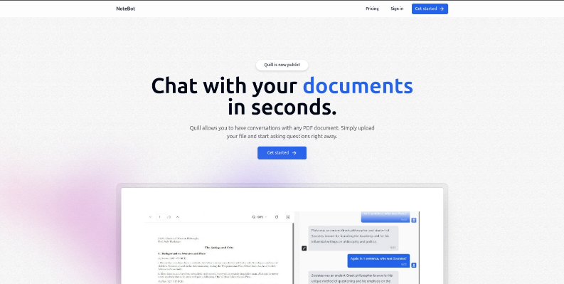
Home Page: The front page presents a clean and inviting interface, emphasizing ease of use with the tagline "Chat with your documents in seconds." It guides users directly to start by uploading a PDF, highlighting the primary function of interacting with document content quickly and intuitively.
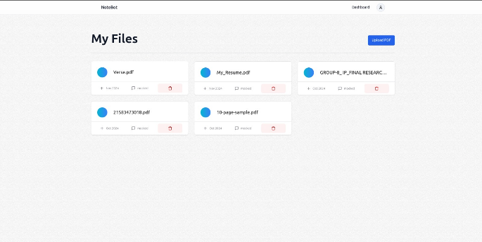
My Files Page: The "My Files" page offers a straightforward layout where users can view and manage their uploaded documents. Each file displays essential information, such as upload date, file size, and options to delete or rename, ensuring smooth organization and accessibility.
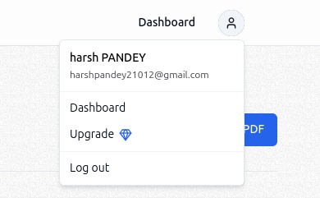
Dashboard: The dashboard offers users access to their profile, account settings, and options like upgrading their plan or logging out. It serves as the main hub for navigating the account's features.
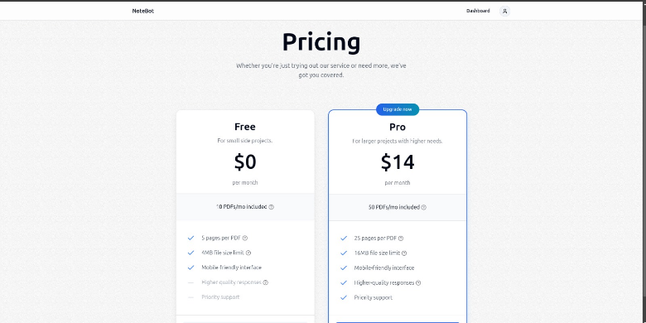
Pricing: Two main subscription plans are available. The "Free" plan offers basic features with limited resources, while the "Pro" plan, at $14 per month, includes additional benefits suited for higher usage needs, such as more projects and premium support.
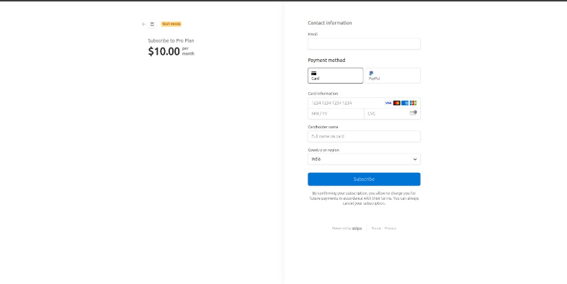
Payment Gateway: The payment gateway allows users to subscribe to a selected plan securely. It collects essential payment information like card details and billing information to process subscriptions.
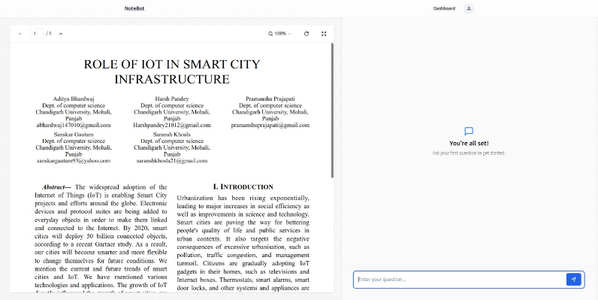
Chat Interface: The chat section provides a user-friendly interface where users can communicate directly with support or other users. It allows for real-time interaction and assistance within the platform.
Chat Features: The chat includes features such as message history, file sharing, and notifications, ensuring users have a seamless communication experience.
Support Accessibility: The chat section offers quick access to customer support, enabling users to ask questions or troubleshoot issues directly with support representatives, enhancing the overall user experience.

- FUTURE SCOPES

The future of the development methodology used to create the “Noteshwar” online music player and code editor offers many opportunities for further advancement and innovation. Here are some potential suggestions for future growth:

Integration of new technologies: As technology continues to evolve, there is great potential for the integration of artificial intelligence (AI) and machine learning (ML) at the forefront of personalized recommendations. For example, AI could be used to identify errors and optimize code in the editor, simplifying the coding process and reducing debugging work. For musicians, advanced machine learning could provide dynamic musical signatures, emotion-based recommendations, and sound changes. Additionally, the exploration of augmented reality (AR) and virtual reality (VR) could enable new three-way experiences where users can interact with music or coding environments in space.

Improving user experience (UX): Improving user experience is important for both music and code editors. Future improvements will include streamlining the user interface and interactions. The combination of natural language processing (NLP) and speech recognition will enable hands-free control of music or coding, making information accessible to a wider audience. Features like customizable grids, dark mode, and changing layouts will allow users to further personalize their experience, creating a more engaging and visually appealing environment.

Instant Collaboration: New collaboration now allows users to work together on music playlists or coding projects in a synchronized manner. This could include features like live chat, simultaneous code editing, and even shared playlists to encourage collaboration and productivity. Instant collaboration will allow multiple users to contribute and make updates simultaneously, improving the overall usability of the platform.

Focus on accessibility: To make the platform more accessible, future developments may prioritize accessibility that caters to users with varying abilities. This will include using screen reader support, keyboard navigation, and resizing to ensure everyone can access Noteshwar.

Automation and continuous integration: Establish DevOps best practices, including continuous integration (CI) and continuous delivery (CD), to support rapid and reliable delivery of new and improved products. Automated testing, deployment, and monitoring processes help maintain code quality and ensure the platform continues to meet user needs and business standards.

Advanced analytics and feedback mechanisms: Using data-driven analytics can provide insight into user behavior and platform performance. By collecting feedback and analyzing user data, developers can identify areas for improvement, track user satisfaction, and respond appropriately to emerging situations and issues.

Cross-platform compatibility: Ensuring that Noteshwar is accessible from a variety of devices, including mobile phones, tablets, and desktops is key to making it accessible and usable. Optimizing the platform’s cross-platform compatibility will help expand its user base and make it more versatile.

Profile Privacy and Security: As additional features are added, it is important to focus on user profile privacy and security. Secure authentication, encrypted storage, and adherence to strong data practices will ensure users have confidence in the privacy of their data while using “Noteshwar.”

ACKNOWLEDGMENT
Our gratitude is expressed to Prof. Sonal Rattan for her help in carrying out our study and project ideas. We would also like to thank the Apex Institute of Technology (AIT) of Chandigarh University for their assistance and advice.

REFERENCES
- G. Eason, B. Noble, and I. N. Sneddon, “On certain integrals of Lipschitz-Hankel type involving products of Bessel functions,” Phil. Trans. Roy. Soc. London, vol. A247, pp. 529–551, April 1955.
- J. Clerk Maxwell, A Treatise on Electricity and Magnetism, 3rd ed., vol.
2. Oxford: Clarendon, 1892, pp.68–73.
- I. S. Jacobs and C. P. Bean, “Fine particles, thin films and exchange anisotropy,” in Magnetism, vol. III, G. T. Rado and H. Suhl, Eds. New York: Academic, 1963, pp. 271–350.
- K. Elissa, “Title of paper if known,” unpublished.
- R. Nicole, “Title of paper with only first word capitalized,” J. Name Stand. Abbrev., in press.
- Y. Yorozu, M. Hirano, K. Oka, and Y. Tagawa, “Electron spectroscopy studies on magneto-optical media and plastic substrate interface,” IEEE Transl. J. Magn. Japan, vol. 2, pp. 740–741, August 1987 [Digests 9th Annual Conf. Magnetics Japan, p. 301, 1982].
- M. Young, The Technical Writer’s Handbook. Mill Valley, CA: Univer- sity Science, 1989.

